## 

|  |  |
| --- | --- |
| FOR IMMEDIATE RELEASE  August 27, 2024  More info: alarmwillsound.com | PRESS CONTACT  Michael Clayville, 717.831.8461  michaelclayville@alarmwillsound.com |

## The Matt Marks Impact Fund supports the development of exciting, ambitious projects with Alarm Will Sound that have the potential to make a significant cultural and social impact.

|  |
| --- |
| **Alarm Will Sound**announces**The 2024 Recipients of the**[***Matt Marks Impact Fund***](https://www.alarmwillsound.com/mmif/) **Sanaya Ardeshir** and **Paul Swartzel** will receive funding to develop and premiere new projects with Alarm Will Sound.  **Sanaya Ardeshir's *Tower of Silence*:**  A long-form piece for ensemble and electronics that reimagines the ancient Parsi funerary customs to explore cultural identity and the connections between human communities and the natural world.  **Paul Swartzel's *The Shitty Titanic*:**  An audio-visual chamber concerto that humorously and poignantly examines mental illness, stigma, and the human condition through the lens of personal experience with schizoaffective disorder. |

#### 

|  |
| --- |
| **From Gavin Chuck, Executive Director of Alarm Will Sound:**  “The Matt Marks Impact Fund continues to make creative space within classical music for new, ground-breaking work that expresses the full range of our society’s artistic and personal perspectives.” |

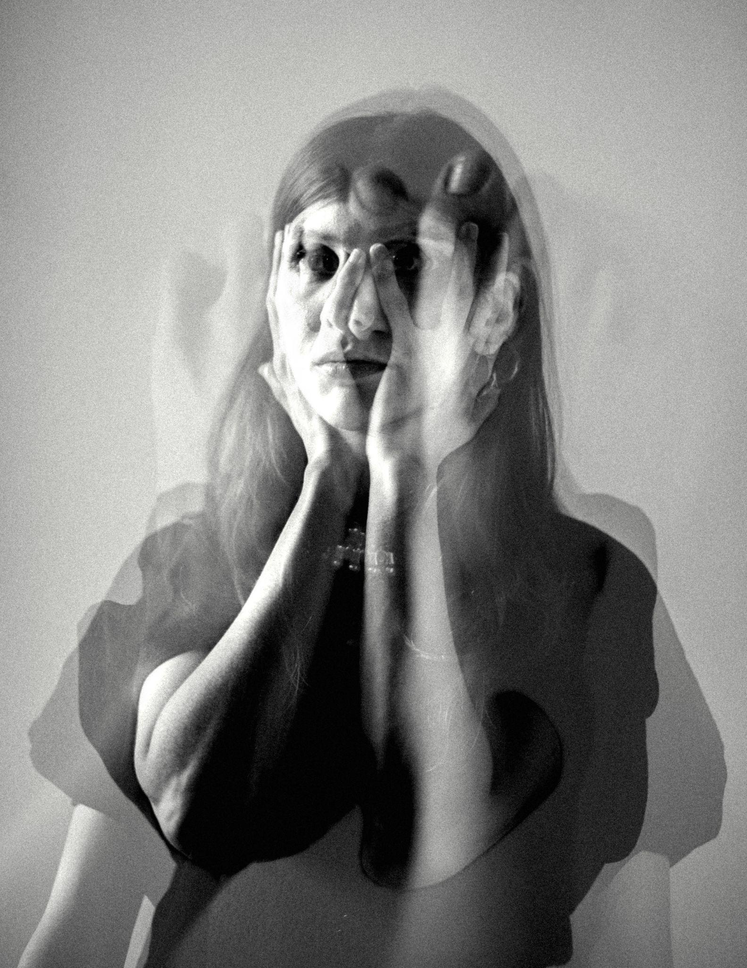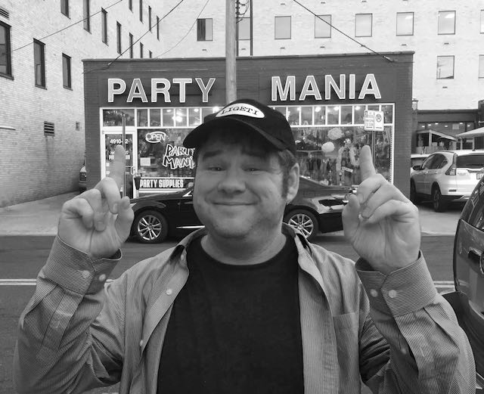

|  |  |
| --- | --- |
| Sanaya Ardeshir | Paul Swartzel |
| *Photo credit:* Sumaiya Sayed | *Photo credit:* Ginger Hunter |

**New York, NY (August 27, 2024)** — [Alarm Will Sound](http://alarmwillsound.com) has selected the [**2024 recipients of the Matt Marks Impact Fund**](http://alarmwillsound.com/mmif): composer and producer **Sanaya Ardeshir** and composer **Paul Swartze**l. Ardeshir's project explores themes of cultural identity and collective memory, while Swartzel's work tackles mental illness and the human condition through a blend of humor and raw emotion. These two exceptional artists will receive seed funding to develop and premiere innovative new projects with Alarm Will Sound, continuing the ensemble's mission to push the boundaries of contemporary music and explore socially impactful themes.

The Matt Marks Impact Fund, named in honor of Alarm Will Sound’s beloved founding member, offers up to $7,500 in seed money to support projects that have the potential to make significant cultural and social impacts. By fostering creativity, experimentation, and collaboration, the Fund aims to break down barriers in the classical music world and support underrepresented voices.

**Sanaya Ardeshir**, a Mumbai-born, Los Angeles-based composer and performer, will develop her project "Tower of Silence." This long-form piece for full ensemble and electronics explores the ancient funerary customs of her Parsi heritage, reimagining the spiritual and cultural significance of the Tower of Silence in today’s world. The work will feature guest vocalists and be presented as both a recorded album and a live performance accompanied by procedural visuals. Ardeshir explains, “This project is a sonic invocation that bridges the past with the present, honoring a tradition that has shaped my community while opening a dialogue about identity, belonging, and the collective memory.” Reflecting on the significance of this opportunity, Ardeshir notes, “It presents an example to other composers who share a common background—that it is possible to progress one's work and skills within this field and medium even if one didn't have access to a university education in music.”

**Paul Swartzel**, a composer and pianist from North Carolina, brings his deeply personal and humorous project "The Shitty Titanic" to life. This audio-visual work, inspired by Swartzel’s experiences living with schizoaffective disorder, is an exploration of mental health, stigma, and the human condition. Swartzel's project will be a chamber concerto for speaker, prepared piano, and chamber orchestra, combining storytelling, music, and visual art to offer an unflinching yet entertaining portrayal of life with a psychotic disorder. “I want to create something that humanizes the experiences of those living with severe mental illness,” Swartzel says. “I’m trying to find humor and connection to help end the stigma.”

**Alan Pierson**, Alarm Will Sound's Artistic Director, reflects on the selection: “Sanaya and Paul are both taking creative risks that align perfectly with the spirit of the Matt Marks Impact Fund. Their projects not only push the boundaries of what music and art can be but also engage with urgent cultural and social issues. We are excited to collaborate with them and bring these powerful works to life.”

Previous recipients of the Matt Marks Impact Fund include Alyssa Pyper, Allison Loggins-Hull and Toshi Reagon, Caroline Louise Miller, Bakudi Scream, Damon Davis, Brittany J. Green, and NNux. Works supported by the Fund have been performed at venues like Carnegie Hall and Walt Disney Concert Hall and released on Cantaloupe Music, reflecting the growing reach and impact of these innovative, socially conscious projects.

**Sanaya Ardeshir**

**Sanaya Ardeshir** (she/her) is an Indian music producer, composer, and performer. Like her naturally occurring namesake, her world of sound is in constant evolution - ranging from experimental piano music, acoustic-electronic dance music, to experiments in pop, field recordings and synthesis. Her performances reveal an appetite for integrating the worlds of studio and stage, where synthesisers and sound controllers are supported by an ensemble of live musicians against a backdrop of audio reactive visuals.

She has been described as “*one of India's leading electronic music artists****”*** ([Resident Advisor](https://ra.co/films/3058)), and her work has garnered praise from international and local tastemakers across various media including [Rolling Stone](https://rollingstoneindia.com/tag/sandunes/), [The Quietus](https://thequietus.com/articles/27391-sandunes-11-11-review), [The Guardian](https://www.theguardian.com/music/2017/sep/20/steve-reich-different-trains-1947), [The Wire](https://www.thewire.co.uk/issues/431), and the [BBC World Service](https://www.bbc.co.uk/programmes/w3ct30l6).

Audiences have seen her perform in a variety of formats, playing at major festivals like Lollapalooza, Roskilde, Womad, and Magnetic Fields; and at iconic venues like the National Centre for Performing Arts, Liberty Cinema, and G5A. Notably, she has performed at London’s Barbican Centre under commission from Warp Records and Boiler Room, toured the U.S. supporting Pretty Lights, opened shows for Grammy-nominated electronic producer - Bonobo, remixed music from Grammy award-nominated Anoushka Shanker, hosted a radio show as part of the BBC Asian Network residency, and released a collaborative album with celebrated UK jazz drummer Richard Spaven.

In addition to releasing music, she also works as a sound designer having most recently composed music and designed sound in spatial audio for a first of it's kind 15-room exhibition titled “*India in Fashion*”, commissioned by the Nita Mukesh Ambani Cultural Centre in Mumbai

The investigative nature of Sandunes' body of work is informed by her interests in community, ecology, mentorship and mindfulness. She has appeared as a guest lecturer at Ableton’s Loop Summit for Music Makers as well as at 'Today at Apple' at India's first Apple store. She is the co-founder of [Ears to the Ground](https://www.ears2theground.org/) - a trans media project with Krishna Jhaveri, that lives in the intersection of art and ecology, through sound-forward spaces, experiences and installations. The project seeks to reinvent itself at every juncture as a young exploration of the oldest Mountain range in India - the Western Ghats.

**Paul Swartzel**

**Paul Swartzel’s** music has been described as “incredibly awesome and super disturbing.” He often attempts to humanize experiences foreign to most audiences, sometimes humorously: These include piano/vocal etudes in overlapping time signatures with manically filthy lyrics, though with heart. Sometimes recreations of his auditory hallucinations. He often plays all of the instruments in his recordings even if unable to keep a steady beat or play the instrument, attempting to find joy and meaning in his life. Paul developed schizoaffective disorder in his late teens (basically both schizophrenia and bipolar disorder); Psychosomatic inflammation led him to relearn piano with limited use of some fingers. He began writing for prepared piano, using objects on strings to play the same pitch of different keys; allowing super fast passages impossible on a regular piano, even with mobility issues. In school, Paul found it weird how academic music writers describe passages as ‘schizophrenic’ when it’s just a shitty flute solo. He won two ASCAP Morton Gould Young Composer Awards and received a PhD in composition from Duke University. His dissertation, Barbeque Man Unleashed, was a professional wrestling ballet/piano concerto filmed with action figures. He now writes music for Me2/, the world’s only orchestra for people with mental illness. One of Paul’s favorite music memories is playing the Jurassic Park soundtrack on piano at a psychiatric hospital and everyone gathering to sing along, hands in the air. Paul likes pinball, gangsta rap, and was once sprayed in the face by a tiger. For more info, visit [paulswartzel.com](http://paulswartzel.com/)

**Alarm Will Sound**

**Alarm Will Sound** is a 20-member band committed to innovative performances and recordings of today’s music. They have established a reputation for performing demanding music with energetic skill. The *New York Times* says that Alarm Will Sound is “one of the most vital and original ensembles on the American music scene.”

With classical skill and unlimited curiosity, Alarm Will Sound takes on music from a wide variety of styles. Its repertoire ranges from European to American works, from the arch-modernist to the pop-influenced. The group itself includes many composer-performers, which allows for an unusual degree of insight into the creation and performance of new work.

Alarm Will Sound is the resident ensemble at the Mizzou International Composers Festival. Held each July at the University of Missouri in Columbia, the festival features eight world premieres by early-career composers.

Alarm Will Sound may be heard on eighteen recordings, including *For George Lewis* | *Autoshchediasms*, their most recent release featuring music of Tyshawn Sorey. Their genre-bending, critically acclaimed *Acoustica* features live-performance arrangements of music by electronica guru Aphex Twin.

In 2016, Alarm Will Sound in a co-production with Opera Theatre of St. Louis, presented the world premiere of the staged version of Donnacha Dennehy’s *The Hunger* at the BAM Next Wave Festival and the Touhill Performing Arts Center.

In 2013-14, Alarm Will Sound served as artists-in-residence at The Metropolitan Museum of Art. During that season, the ensemble presented four large ensemble performances at the Met, including two site-specific productions staged in museum galleries (*Twinned,* a collaboration with Dance Heginbotham and *I Was Here I Was I,* a new theatrical work by Kate Soper and Nigel Maister).

In 2011, at Carnegie Hall, the group presented *1969*, a multimedia event that uses music, images, text, and staging to tell the compelling story of great musicians—John Lennon, Karlheinz Stockhausen, Paul McCartney, Luciano Berio, Yoko Ono, and Leonard Bernstein—striving for a new music and a new world amidst the turmoil of the late 1960s.

Alarm Will Sound has been presented by Carnegie Hall, Lincoln Center, (le) Poisson Rouge, Miller Theatre, Brooklyn Academy of Music, the Kitchen, the Bang on a Can Marathon, Disney Hall, Kimmel Center, Library of Congress, the Walker Arts Center, Cal Performances, Stanford Lively Arts, Duke Performances, and the Warhol Museum. International tours include the Holland Festival, Sacrum Profanum, Moscow’s Art November, St. Petersburg’s Pro Arte Festival, and the Barbican.

The members of the ensemble have also demonstrated our commitment to education through residency performances and activities at the Eastman School of Music, Manhattan School of Music, Princeton University, New York University, and Massachusetts Institute of Technology.

For more information, visit Alarm Will Sound’s website at [www.alarmwillsound.com](https://docs.google.com/a/alarmwillsound.com/document/edit?id=1ieh7tTBTkA_ZxT1cFlvy7lm-qKN2o9LcbyBUH8wBhYA&hl=en)

For further information, photos, and to arrange interviews,

please contact Michael Clayville at 717.831.8461 or michaelclayville@alarmwillsound.com.

# # #