

FOR IMMEDIATE RELEASE  June 3, 2024  More info: alarmwillsound.com | PRESS CONTACT  Michael Clayville, 717.831.8461  michaelclayville@alarmwillsound.com

Alarm Will Sound

announces

Mark Morris Joins Creative Team for
What Belongs to You
An Opera for Tenor and Chamber Orchestra by David T. Little
Based on the Novel by Garth Greenwell
Performed by Karim Sulayman and Alarm Will Sound

Modlin Center for the Arts
September 26 & 28, 2024

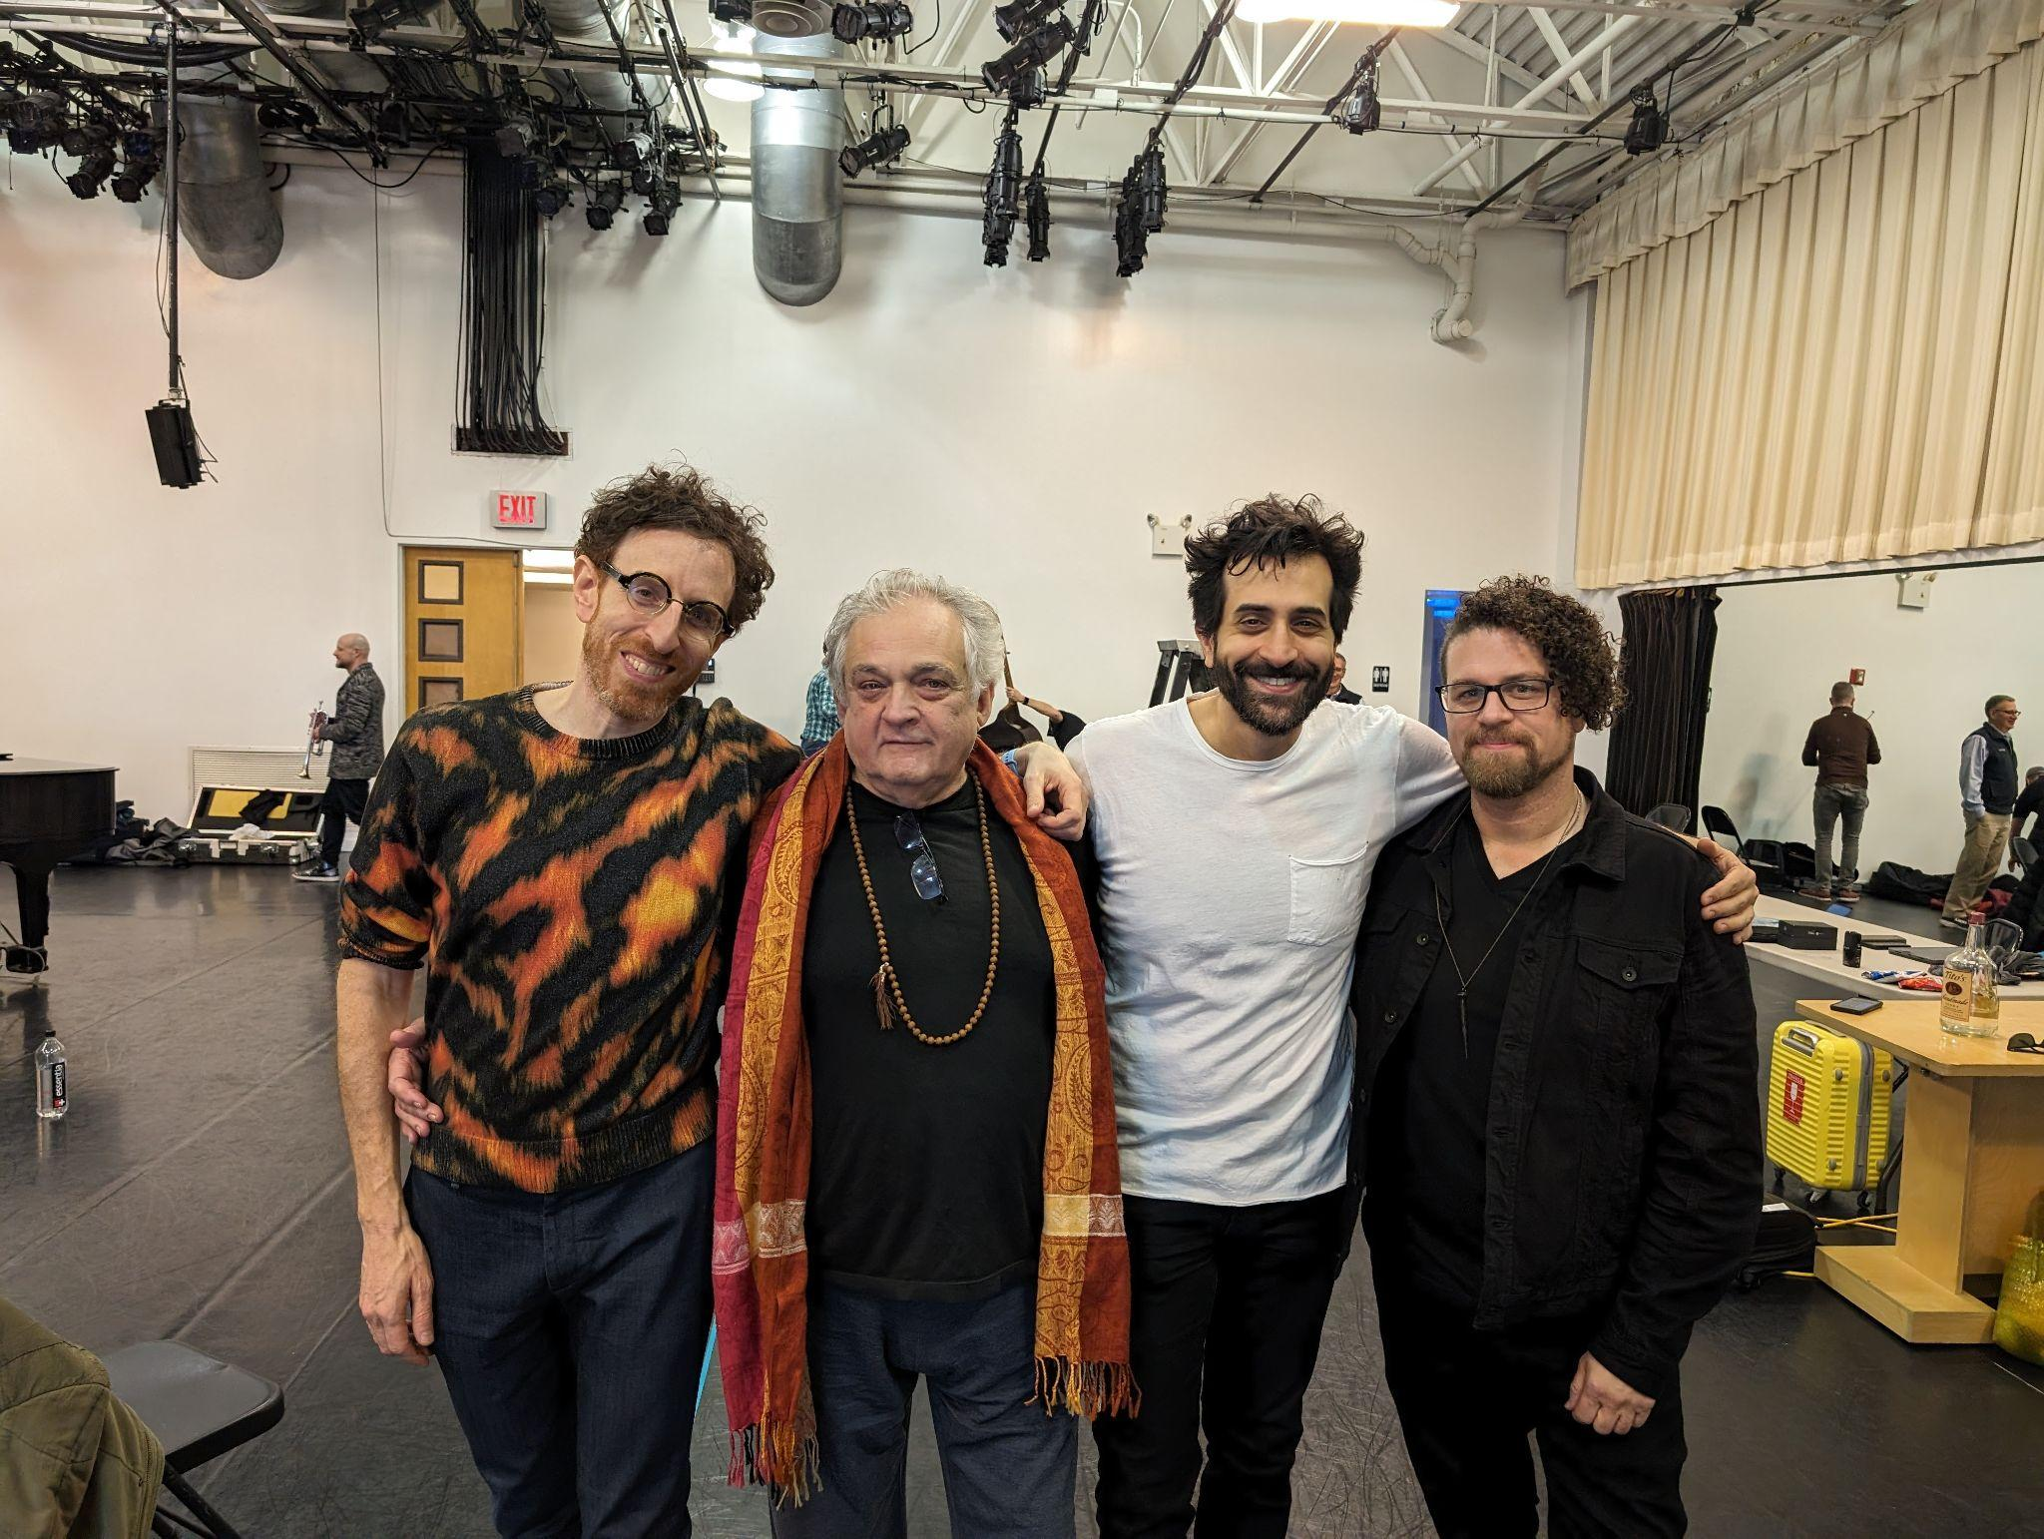

[What Belongs to You] “tells the story of a man caught between longing and resentment, unable to separate desire from danger, and faced with the impossibility of understanding those he most longs to know.” - Garth Greenwell

Watch Alarm Will Sound Workshop What Belongs to You

World Premiere Performances:
September 26 and 28, 2024 at 7:30 pm

Location:
University of Richmond
Modlin Center for the Arts
453 Westhampton Way, Richmond, VA 23173

Tickets:
https://modlin.richmond.edu/

“Alarm Will Sound is one of those ensembles that you can simply trust to have put together an interesting and fulfilling concert, whatever it is that they are playing.”
– The New York Times

New York, NY (June 3, 2024) — Renowned choreographer and director Mark Morris has joined the creative team for What Belongs to You, an opera for tenor and chamber orchestra by GRAMMY® Award-nominated composer David T. Little. Based on Garth Greenwell's acclaimed novel, Morris will direct the opera featuring GRAMMY® Award-winning tenor Karim Sulayman and performed by the contemporary ensemble Alarm Will Sound. What Belongs to You receives its world premiere at Modlin Center for the Arts at the University of Richmond (VA) on Thursday, September 26, 2024 and Saturday, September 28, 2024 at 7:30pm with set and costume design by Maile Okamura and lighting design by Nicole Pearce. A commercial recording of the opera will follow.

What Belongs to You, as Greenwell describes it, “tells the story of a man caught between longing and resentment, unable to separate desire from danger, and faced with the impossibility of understanding those he most longs to know.” This manifests as an infatuation with a hustler named Mitko, with whom the unnamed narrator – here simply called “The American” – begins a long, unstable, and ultimately destructive affair. Little, who is the composer and librettist for the piece, shares: “The story is specific and personal, but the experience Greenwell describes is universal: the search for self and the desire to belong amidst loneliness and enduring heartbreak.”

The collaborators on this project have deep and long-standing connections. Greenwell studied opera at the Eastman School of Music in the late 1990s, where he became close with Alan Pierson and Karim Sulayman, who had gone to high school together at the Northwestern University High School Music Institute. During their time in college, Pierson was Greenwell's accompanist, and Greenwell served on the board of the Eastman’s student organization, Ossia, which laid the foundation for Alarm Will Sound. Pierson served as Music Director for Little's groundbreaking early opera, Dog Days (2012), and later introduced Little to Greenwell, who has granted the composer special license and creative trust to capture the lyrical spirit of his novel and distill it into a 90-minute staged work.

Mark Morris, reflecting on his involvement, shares: “I have followed Alarm Will Sound’s work for years and have always appreciated their aesthetic and forward-thinking approach to music and performance. When I read Garth Greenwell's novel, I was immediately convinced of the project's potential. The story is so rich and emotionally intense. It's a privilege to be part of bringing this powerful, intimate narrative to the stage.”

Pierson says, “It's been such a thrill to bring together these artists, who connect to the deepest and most meaningful chapters of my own artistic and personal life. And I couldn't be more thrilled by the brilliant work that's emerged from this collaboration."

Little takes up Greenwell’s text as the starting point for an opera in his own inimitable style. Known for music that probes the deep corners of psychology, invoking political, historical, spiritual, and social themes as pathways to explore the human condition, Little approaches What Belongs to You as a chance to reflect an evolution in his compositional energy and a turning inward, looking back to look forward; leaning away from the rock bombast of his recent GRAMMY® Award-nominated opera Black Lodge, toward something more introspective, informed more by Monteverdi than Metallica.

For this work, Little sourced inspiration from Britten, Dowland, Monteverdi, Valentini, Schubert, and Grisey; reflecting the seriousness of devotion found in artists like Zurbarán and the patina of fading beauty evoked by vanitas paintings. Greenwell’s novel likewise turns to language that imbues a kind of spiritual transcendence into the erotic, a quality seen in many of his own literary influences: James Baldwin, Henry James, Jean Genet, and St. Augustine, his favorite writer. Beginning with his debut, What Belongs to You, these themes continue with his 2020 novel Cleanness and his forthcoming release, due September 3, 2024, Small Rain.

As Greenwell has said about his own work and its connection to St. Augustine: “by turning inward one somehow arrives at a revelation, a truth that can be communicated to others.” Little shares, “This is the very experience that moved me so tremendously when first reading What Belongs to You. It is what drew me to it, made me cherish it and feel the sacred in it. It is what inspired me to give it a life in music and on stage. It is my hope that through this performance, the audience may also find something meaningful, and true.”

Program Information
Thursday, September 26, 2024 at 7:30pm
Saturday, September 28, 2024 at 7:30pm
Modlin Center for the Arts | Richmond, VA
Link: https://modlin.richmond.edu/

What Belongs to You [World Premiere]
an opera by David T. Little
Based on the novel by Garth Greenwell

Karim Sulayman as “The American”
Alarm Will Sound

Alan Pierson, Conductor
Mark Morris, Director
Maile Okamura, Set and Costume Design
Nicole Pearce, Lighting Design

What Belongs to You was commissioned by Alarm Will Sound and the Modlin Center for the Arts at the University of Richmond, with the kind support of Linda H. and Richard N. Claytor, Ph.D., and Andrew Martin-Weber.

*What Belongs to You contains adult themes and language and is intended for mature audiences.

About the Artists
A natural musical storyteller with “a knack for overturning musical conventions” (The New York Times), composer and librettist David T. Little is known for stage, concert, and screen works permeated with the power of the unexpected. Little’s broad catalog speaks to the mix of light and dark that we experience in life, unafraid to invoke the mythical, bewitching, disturbing, surreal, or comedic. His recent work Black Lodge was nominated for Best Opera Recording in the 2023 GRAMMY® Awards. David T. Little has drawn acclaim for operas including Dog Days, JFK, and the comedy Vinkensport, or The Finch Opera (all with libretto by Royce Vavrek), as well as his GRAMMY®-nominated opera, Soldier Songs. Little’s Black Lodge, a metal-infused opera with a libretto by poet Anne Waldman, was premiered by Beth Morrison Projects at Opera Philadelphia, with a soundtrack released by Cantaloupe Music. As the recent recipient of a Music Theater Now international prize, it received its European premiere at the O. Festival in Rotterdam this May. His SIN-EATER was premiered by The Crossing at Penn Live Arts. He is at work on a commission from the Metropolitan Opera / Lincoln Center Theater New Works Program, as well as several other new stage, film, and concert projects. Little’s music is published by Boosey & Hawkes. Learn more at www.davidtlittle.com.

Garth Greenwell is the author of What Belongs to You, which won the British Book Award for Debut of the Year, was longlisted for the National Book Award, and was a finalist for six other awards, including the PEN/Faulkner Award, the James Tait Black Memorial Prize, and the Los Angeles Times Book Prize. A New York Times Book Review Editors' Choice, it was named a Best Book of 2016 by over fifty publications in nine countries, and is being translated into fourteen languages. His second book of fiction, Cleanness, was a finalist for the Lambda Literary Award and was longlisted for the Gordon Burn Prize, the Joyce Carol Oates Prize, the L.D. and LaVerne Harrell Clark Fiction Prize, and France’s Prix Sade (Deuxième sélection). A new novel, Small Rain, is forthcoming from FSG in 2024. His fiction has appeared in The New Yorker, The Paris Review, A Public Space, and VICE, and he has written nonfiction for The New Yorker, the London Review of Books, and Harper’s, among others. He writes regularly about literature, film, art and music for his Substack, To a Green Thought. He is the recipient of many honors for his work, including a 2020 Guggenheim Fellowship and the 2021 Vursell Award for prose style from the American Academy of Arts and Letters. He has taught at the Iowa Writers Workshop, Grinnell College, the University of Mississippi, and Princeton. Greenwell currently lives in New York, where he is a Distinguished Writer-in-Residence at NYU. Learn more at www.garthgreenwell.com

Mark Morris was born in Seattle, where he studied with Verla Flowers and Perry Brunson. In the early years of his career, he performed with the companies of Lar Lubovitch, Hannah Kahn, Laura Dean, Eliot Feld, and the Koleda Balkan Dance Ensemble. He formed the Mark Morris Dance Group (MMDG) in 1980 and has since created over 150 works for the company. From 1988 to 1991, he was Director of Dance at the Théâtre Royal de la Monnaie in Brussels, the national opera house of Belgium. In 1990, he founded the White Oak Dance Project with Mikhail Baryshnikov. Noted for his musicality, Morris has been described as “undeviating in his devotion to music” (The New Yorker). He began conducting performances for MMDG in 2006 and has since conducted at Tanglewood Music Center, Lincoln Center, and BAM (Brooklyn Academy of Music). In 2013, he served as Music Director for the Ojai Music Festival. Morris also works extensively in opera, directing and choreographing productions for The Metropolitan Opera, New York City Opera, English National Opera, and The Royal Opera, Covent Garden, among others. He was named a Fellow of the MacArthur Foundation in 1991 and has received eleven honorary doctorates to date. He has taught at the University of Washington, Princeton University, and Tanglewood Music Center. Morris opened the Mark Morris Dance Center in Brooklyn, New York, in 2001 to provide a home for his company, subsidized rental space for local artists, community education programs for children and seniors, and a school offering dance classes to students of all ages and levels of experience with and without disabilities. Learn more at www.markmorrisdancegroup.org.

Alarm Will Sound is a 20-member band committed to innovative performances and recordings of today’s music, which has established a reputation for performing demanding music with energetic virtuosity. With classical skill and unlimited curiosity, Alarm Will Sound takes on music from a wide variety of styles. “Stylistically omnivorous and physically versatile” (The Log Journal), their repertoire comes from around the world, and ranges from the arch-modernist to the pop-influenced. Since its inception, Alarm Will Sound has been associated with composers at the forefront of contemporary music. The group itself includes many composer-performers, which allows for an unusual degree of insight into the creation and performance of new work. Alarm Will Sound is the resident ensemble at the Mizzou International Composers Festival. Held each July at the University of Missouri in Columbia, the festival features eight world premieres by early-career composers. In 2013-14, Alarm Will Sound served as artists-in-residence at The Metropolitan Museum of Art. Alarm Will Sound may be heard on 18 recordings, including For George Lewis | Autoshchediasms, their most recent release featuring music of Tyshawn Sorey, and the premiere recording of Steve Reich’s Radio Rewrite. Acoustica, their genre-bending, critically-acclaimed album, features live-performance arrangements of music by electronica guru Aphex Twin. For more information visit www.alarmwillsound.com.

Alan Pierson has been praised as "a dynamic conductor and musical visionary" by The New York Times, a "conductor of monstrous skill" by Newsday, "gifted and electrifying" by the Boston Globe, and "one of the most exciting figures in new music today" by Fanfare. In addition to his work as artistic director of Alarm Will Sound, he has served as Artistic Director of the Brooklyn Philharmonic, and guest conducted the Los Angeles Philharmonic, the Chicago Symphony Orchestra, the Hamburg Symphony Orchestra, L.A. Opera, Nationaltheater Mannheim, the London Sinfonietta, the Steve Reich Ensemble, the Orchestra of St. Luke's, the New World Symphony, and the Silk Road Project, among others. He is co-director of the Northwestern University Contemporary Music Ensemble, and has been a visiting faculty conductor at the Indiana University Jacobs School of Music, the Eastman School of Music, and at the Banff Centre for the Arts and Creativity. Passionate about using storytelling to bring listeners inside of contemporary music, he has led the creation of innovative musical experiences, like Alarm Will Sound's 1969 and Soundbites video series, and the Brooklyn Philharmonic's Brooklyn Village project. Mr. Pierson has collaborated with major composers and performers, including Yo Yo Ma, Steve Reich, Dawn Upshaw, Osvaldo Golijov, John Adams, John Luther Adams, Augusta Read Thomas, David Lang, Michael Gordon, La Monte Young, and choreographers Mark Morris, Christopher Wheeldon, Akram Khan, and Elliot Feld. Mr. Pierson received bachelor degrees in physics and music from the Massachusetts Institute of Technology, and a doctorate in conducting from the Eastman School of Music. He has recorded for Nonesuch Records, Cantaloupe Music, Sony Classical, Oehms Classics, and Sweetspot DVD.

Lebanese-American tenor Karim Sulayman has garnered international attention as a sophisticated and versatile artist, praised for his “lucid, velvety tenor and pop-star charisma” (BBC Music Magazine). He earns widespread acclaim for his innovative programming and recording projects while performing on the world’s stages in opera, orchestral concerts, recital and chamber music. Upcoming engagements include his debut at the Royal Opera House as the title role in Sarah Angliss/Ross Sutherland’s Giant, the world premiere of Layale Chaker/Lisa Schlesinger’s Ruinous Gods and Haydn’s Creation at the Spoleto Festival USA, and the world premiere of David T. Little’s monodrama, What Belongs to You (based on Garth Greenwell’s acclaimed novel), written for Sulayman and Alarm Will Sound, directed by Mark Morris. Mr. Sulayman won the 2019 GRAMMY® Award for Best Classical Solo Vocal Album for his debut solo disc, Songs of Orpheus (Avie Records). His second album, Where Only Stars Can Hear Us (Avie Records) with fortepianist Yi-heng Yang, debuted at #1 on the Billboard Traditional Classical Chart and was included in The New York Times’ Best Classical Music of 2020. His third solo album, Broken Branches (Pentatone), with guitarist Sean Shibe, debuted at #1 on the UK Classical Chart and was recently nominated for the 2024 GRAMMY® Award for Best Classical Solo Vocal Album and was named one of the Best Classical Albums of 2023 by The New York Times. Learn more at www.karimsulayman.com.

# # #

